GENERAL INFORMATION SHEET

1 ST INTERNATIONAL DIVING MEET
TATARSTAN PRESIDENT’S DIVING CUP

Kazan Aquatics Palace, Kazan, Russia
November 30 – December 5, 2018

Russia’s Diving Federation has the honor and pleasure to invite you to the 1st International Diving Meet TATARSTAN PRESIDENT’S DIVING CUP, to be held in Kazan, Russia, on November 30 - December 5, 2018.
The following information has been designed to assist your National Federation in its attendance at this event.
EVENT CONTACTS

Should you have any questions or queries regarding the information provided in this document, please feel free to contact the following Organizing Committee event staff:

Local Organising Committee Kazan

Event Director
Mr. MUYAKIN PAVEL
tel: +79872054758, e-mail: muyakin@yandex.ru
Mr. NAGUMANOV SAID
tel: +79872055561, e-mail: said-nagumanov@mail.ru

PARTICIPANTS
Age groups:

group A 16/17/18 years (born 2000/2001/2002)
group B 13/14/15 years (born 2003/2004/2005)
Younger participants can take part in events of age group B (appropriate to the
FINA rules).

ONE TEAM PER ONE COUNTRY SHOULD CONSIST OF 8 ATHLETES, 1 COACH AND 1 JUDGE. ACCOMMODATION AND MEALS AT THE ORGANIZING COMMITTEE OWN EXPENSES.

Events:
1m / 3m / 5m, 7,5m, 10m platform (age group A / B) and
3m-synchronized (age group A / B combined)

ENTRY PROCESS AND PROTOCOL

All preliminary entries shall be sent no later then November 1, 2018.

IMPORTANT DATES TO NOTE

Arrival in Kazan: November 30, 2018
Technical Meeting: 17:00 PM on November 30, 2018
Competition: December 1 – December 4, 2018
Departure from Kazan: December 5, 2018

COMPETITION INFORMATION

Training Dates:
November 30, 2018, Kazan Aquatics Palace
Training Schedule: 08:00-20:00

Technical Meeting: The HMF/OC shall organise a Technical Meeting on November 30, 2018
Competition Dates: December 1 - December 4, 2018.

SCHEDULE

December 1,2018  10:00  PRELIMINARY COMPETITIONS. | BOYS GROUP B SPRINGBOARD 1M  GIRLS GROUP A 5m, 7,5m, 10m PLATFORM  BOYS GROUP A SPRINGBOARD 1M
15:30 | OPENING CEREMONY
16:00  FINALS | BOYS GROUP B SPRINGBOARD 1M  GIRLS GROUP A 5m, 7,5m, 10m PLATFORM  BOYS GROUP A SPRINGBOARD 1M
December 2,2018  10:00  PRELIMINARY COMPETITIONS | GIRLS GROUP B SPRINGBOARD 1M  BOYS GROUP B 5m, 7,5m, 10m PLATFORM  GIRLS GROUP A SPRINGBOARD 3M
16:00  FINALS | GIRLS GROUP B SPRINGBOARD 1M  BOYS GROUP B 5m, 7,5m, 10m PLATFORM  GIRLS GROUP A SPRINGBOARD 3M  SPRINGBOARD 3M SYNCHRO GIRLS A/B
December 3,2018  10:00  PRELIMINARY COMPETITIONS | BOYS GROUP B SPRINGBOARD 3M  GIRLS GROUP B 5m, 7,5m, 10m PLATFORM  BOYS GROUP A SPRINGBOARD 3M
16:00  FINALS | BOYS GROUP B SPRINGBOARD 3M  GIRLS GROUP B 5m, 7,5m, 10m PLATFORM  BOYS GROUP A SPRINGBOARD 3M  SPRINGBOARD 3M SYNCHRO BOYS A/B
December 4,2018  10:00  PRELIMINARY COMPETITIONS | GIRLS GROUP A SPRINGBOARD 1M  GIRLS GROUP B SPRINGBOARD 3M  BOYS GROUP A 5m, 7,5m, 10m PLATFORM
16:00  FINALS | GIRLS GROUP A SPRINGBOARD 1M  GIRLS GROUP B SPRINGBOARD 3M  BOYS GROUP A 5m, 7,5m, 10m PLATFORM
 | CLOSING CEREMONY

VENUE INFORMATION

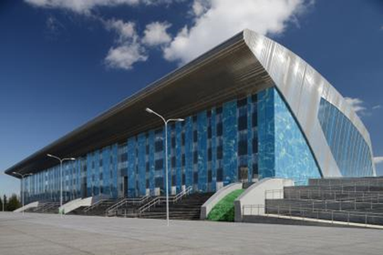 | 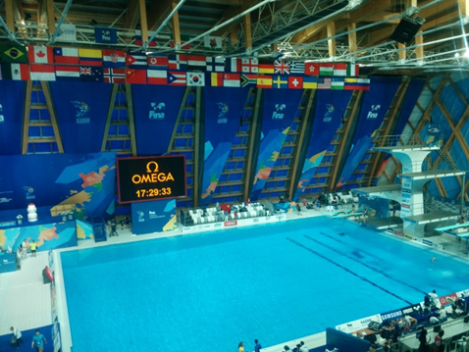

General information: Kazan Aquatics Palace,
Aquatics Palace, 70 S.Khakima str., Kazan, Russia
Athletes’ preparation area (locker rooms, dry land) is located on the ground floor, as well as competition management offices, FINA offices and Doping control area. Press centre with conference hall and VIP zone are located on the 3rd floor, 2nd and 4th floors are dedicated to spectators. Parking: 942 cars. Venue is available for disabled people.

Facilities
There are two 1m springboards, two 3m springboards, one platform at 1m, 3m, 5m, 7.5m and 10m. A hot tub and showers underneath the Diving platforms will be provided for athletes to keep warm during training and competition.

Dry land
Diving dry land facilities will be available at the competition venue, providing the following equipment: One (1) tumbling (15 m), one (1) platform (3 m), four (4) springboards (1m), two (2) trampolines (3x5m), three (3) stretching mats (4 x 2.6 m), and jumping pit 6.2 х 5.3 m, spotting rigs.

EVENT INFORMATION DESK

Event information desk will be posted at the Venue near secretary room and on the poolside under the platforms.

ACCREDITATION, ACCREDITATION DESK

Accreditation desk will be deployed at the Venue.

RULES

The competitions will be conducted under FINA rules.

VISA INFORMATION

Visa assistance will be provided to those National Federations that need Russian visa.

Please note that the validity of passport must have a minimum expiry date of six (6) months following the last date of departure.
Please send all passport copies to the following e-mail diving-roc@mail.ru no later than the 1st of NOVEMBER, 2018 in order to send you the invitation letter.

TRANSPORTATION

Transportation between Kazan International Airport/railway terminals and the official hotels, also between the official hotel “Universiade Village” and the venue will be provided by the Organising Committee.
Please make sure that your flight details are included in your registration in the FINA GMS in order to ensure that your transportation to and from Kazan International Airport/railway terminals is arranged correctly.

ACCOMMODATION AND MEALS

Teams

The official hotel for the Teams will be UNIVESIADE VILLAGE, located not far from the Venue (20 min. by bus). Address: 420055, 16A, Universiade village str., Kazan, Russia.
Please note that all extra days/nights are paid by Teams.

Room Rate at the Official Hotel (full board and lodging for extra person or day):

Twin room and triple rooms: USD 40 per person per night

NOTE!!! Payment (full board and lodging for extra persons or day) should be made by cash ONLY in US dollars on arrival in Kazan to the representative of Organizing Committee.

Please send the accommodation forms to tatarstandiving@mail.ru

The deadline for accommodation requests is November 5, 2018

